Practical 7
Study of Various Devices:
- Printers:

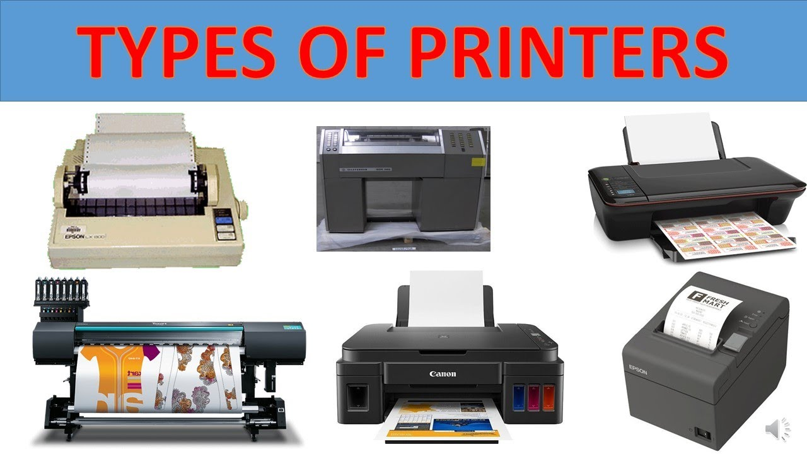

A printer is a device that produces a physical, hard copy of digital information, typically text or images, on paper or other media. It acts as an output device, converting data from a computer or other device into a tangible, visible form. Printers are widely used in both personal and professional settings for various purposes, including document printing, photo printing, and more.

- Scanners
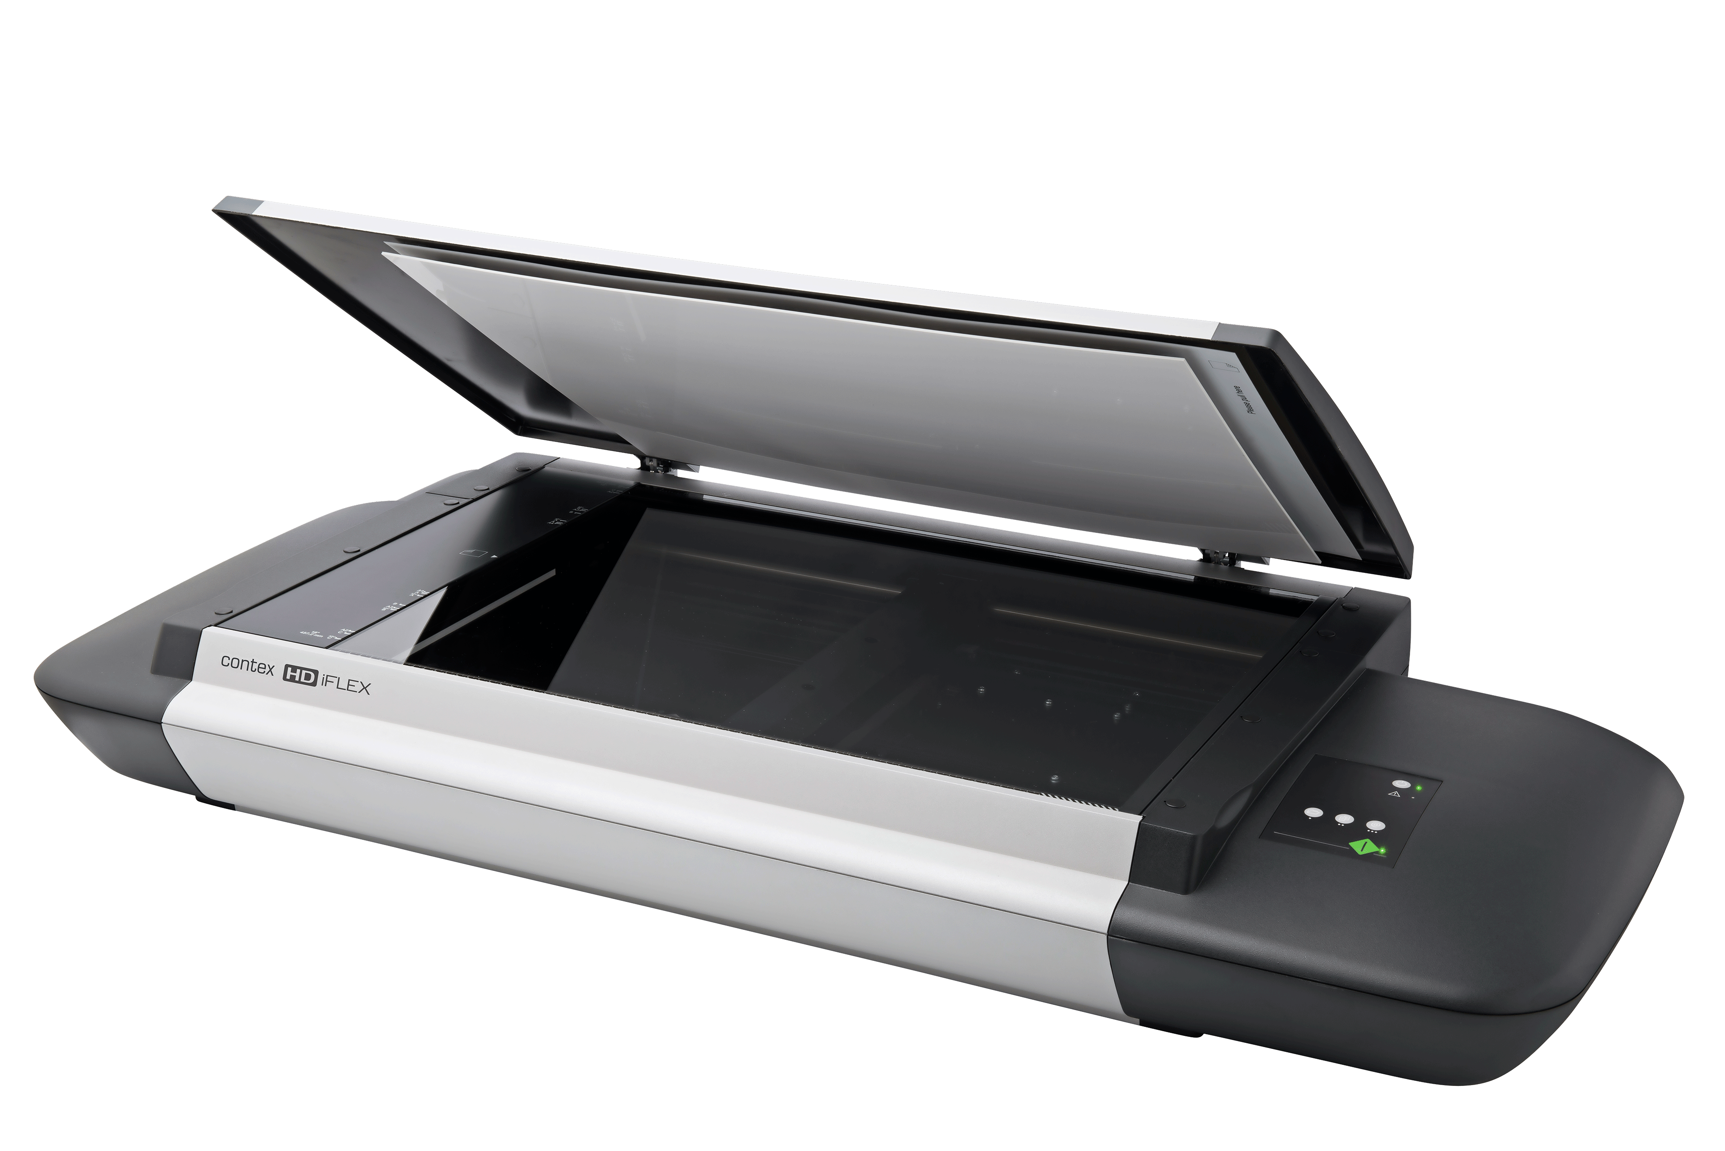

A scanner is a device that converts physical documents, images, or even objects into a digital format that can be stored, edited, and shared on a computer. It acts as an input device, capturing the content of a physical item and transforming it into a digital file.

- Bluetooth
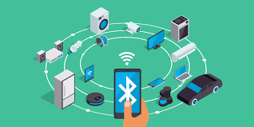

Bluetooth is a wireless technology that allows devices to communicate and exchange data over short distances using radio waves. It's commonly used to connect devices like smartphones, headphones, speakers, and other peripherals without the need for cables. Bluetooth operates on the 2.4 GHz frequency band and is a type of Wireless Personal Area Network (WPAN).

- Modem
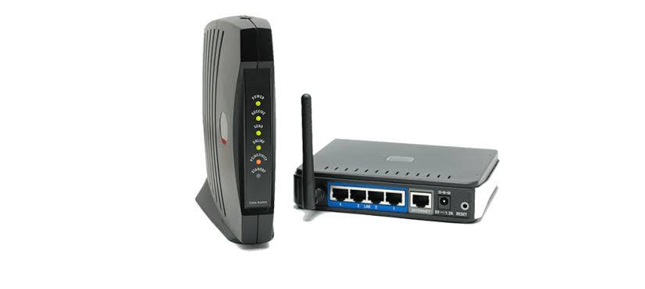
A modem is a device that connects your home network to the internet by converting digital signals from your devices into a format that can be transmitted over the internet infrastructure (like cable or phone lines) and vice versa. It acts as a bridge, enabling communication between your devices and the wider internet.

- Projector
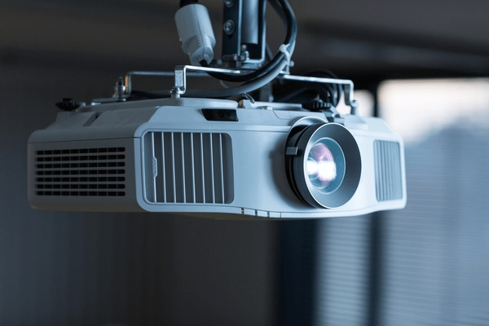

A projector is an optical device that displays images or videos onto a screen or other surface. It works by shining a light through a lens, which magnifies and focuses the light to create a larger image. Projectors are used in various settings, from presentations in conference rooms to home theaters.

